Screenshots:

[Rewards Points Summary by Month](http://localhost:3000/CustRewardinfo)

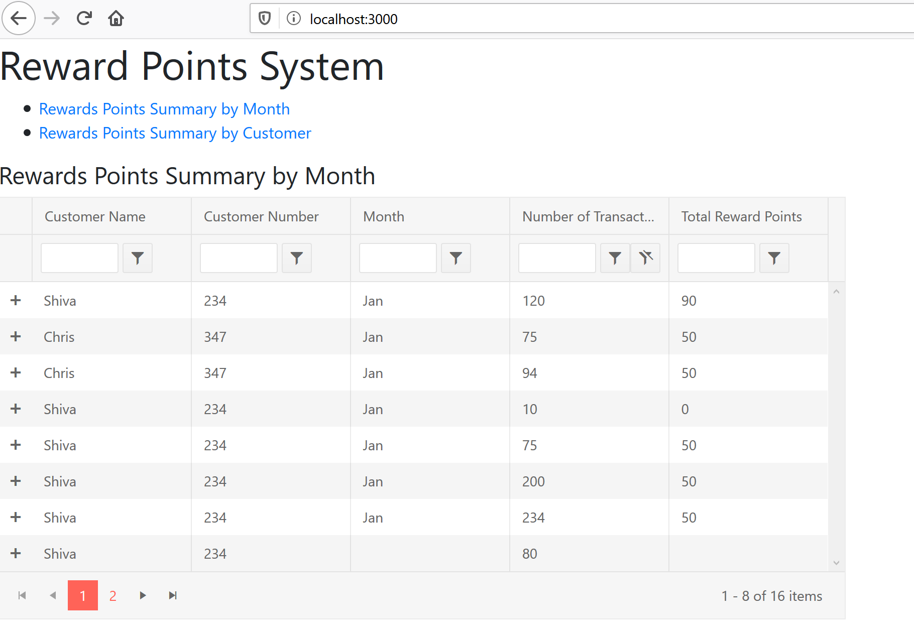

[Rewards Points Summary by Customer](http://localhost:3000/TotalRewards)

